Experiment 3: Bubble Sort with Big-O Analysis

Aim
To write a Python program to sort an array using Bubble Sort and analyze its Big-O time complexity.

Algorithm
- Start.
- Read an array of elements.
- Compare adjacent elements.
- If the first element is greater than the second, swap them.
- Repeat the comparison for all adjacent elements.
- After each pass, the largest unsorted element moves to its correct position.
- Repeat until the array is sorted.
- Display the sorted array.
- Stop.

Source Code
def bubble_sort(arr):
n = len(arr)

for i in range(n):
for j in range(0, n - i - 1):
if arr[j] > arr[j + 1]:
arr[j], arr[j + 1] = arr[j + 1], arr[j]

return arr

arr = [64, 34, 25, 12, 22, 11, 90]

print("Before Sorting:", arr)

bubble_sort(arr)

print("After Sorting:", arr)

Output :

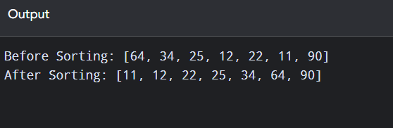

Result :

Thus, the Python program was successfully executed and the given array was successfully sorted in ascending order using Bubble Sort.

